Art and design are integral aspects of human culture and creativity that have been evolving and shaping our world for centuries. They encompass a wide range of disciplines, styles, and mediums, each with its unique history, purpose, and aesthetic principles. In this introduction, we will explore the fundamental concepts and the significance of art and design in society.

**Art**:

Art is a broad and multifaceted field that involves the creation of visual, auditory, or performance artifacts that express the artist's imaginative, conceptual, or technical skills. It serves various functions, including:

1. **Expression**: Art allows individuals to express their thoughts, emotions, and experiences in a visual or auditory format. It can be a powerful means of communication and personal exploration.

2. **Aesthetics**: Art often focuses on aesthetics, exploring the concept of beauty and the creation of visually pleasing or thought-provoking compositions.

3. **Cultural Reflection**: Art reflects the culture, values, and beliefs of a society or a specific time period. It serves as a historical and sociocultural record.

4. **Entertainment**: Art is frequently used for entertainment purposes, as seen in the performing arts, cinema, and music.

5. **Social Commentary**: Many artists use their work to comment on contemporary issues, sparking discussion and raising awareness.

**Design**:

Design, on the other hand, is a purposeful and problem-solving approach to creating functional and aesthetically pleasing objects, spaces, or systems. It plays a critical role in various industries and sectors, including:

1. **User-Centered Design**: In product design, user interface (UI) and user experience (UX) design, the focus is on creating products and interfaces that are intuitive and user-friendly.

2. **Architectural Design**: Architects design structures and spaces that are functional, safe, and visually appealing.

3. **Graphic Design**: Graphic designers create visual materials such as logos, posters, and websites to convey information and messages effectively.

4. **Fashion Design**: Fashion designers conceptualize and create clothing and accessories, influencing trends and personal style.

5. **Industrial Design**: Industrial designers work on products and systems to improve their functionality and aesthetics.

Art and design often intersect and influence one another, as many artists incorporate design principles into their work, and designers draw inspiration from artistic movements and trends. Both fields are vital for fostering creativity, innovation, and human expression. They enrich our lives, impact our perceptions, and can provoke thought, emotion, and change.

Throughout history, art and design have evolved with advancements in technology, shifts in societal norms, and changes in artistic movements. They continue to adapt and reinvent themselves, making them not only cultural artifacts but also a reflection of the times in which they are created.

In this exploration of art and design, we will delve deeper into the various disciplines, historical movements, influential artists and designers, and the ever-evolving nature of these creative fields.

The introduction to a discussion about art and design serves several purposes:

1. **Engagement**: The introduction should grab the reader's or audience's attention and pique their interest. This can be achieved through a compelling anecdote, a thought-provoking question, or a brief overview of the topic's significance in the context of art and design.

2. **Context**: It provides context for the discussion by setting the stage and explaining the relevance of the topic. This may involve mentioning the historical or cultural significance of art and design, or how it impacts our daily lives.

3. **Thesis Statement**: It often includes a clear thesis statement, which is a concise summary of the main point or argument you will be making in the discussion. For example, you might state that you're going to explore the role of art and design in shaping our visual culture or discuss the impact of innovative design on product functionality.

4. **Scope**: The introduction helps define the scope of your discussion. It can briefly outline what specific aspects of art and design you will be focusing on, whether it's the history of a particular art movement, the principles of design, or the role of art in contemporary society.

5. **Importance**: The introduction should convey why the topic of art and design is important. It might touch on how art and design influence emotions, culture, technology, or business. This helps your audience understand why they should care about the topic.

6. **Outline**: In some cases, the introduction may provide a brief outline of the main points or subtopics you will cover in your discussion. This gives your audience a roadmap for what to expect.

Overall, the introduction to a discussion about art and design should set the tone, establish the context, and motivate the audience to continue reading or listening while offering a clear sense of the main themes and arguments you will explore.

**.**

**PROBLEM DEFINITION & DESIGN THINKING**

**EMPATHY MAP:**

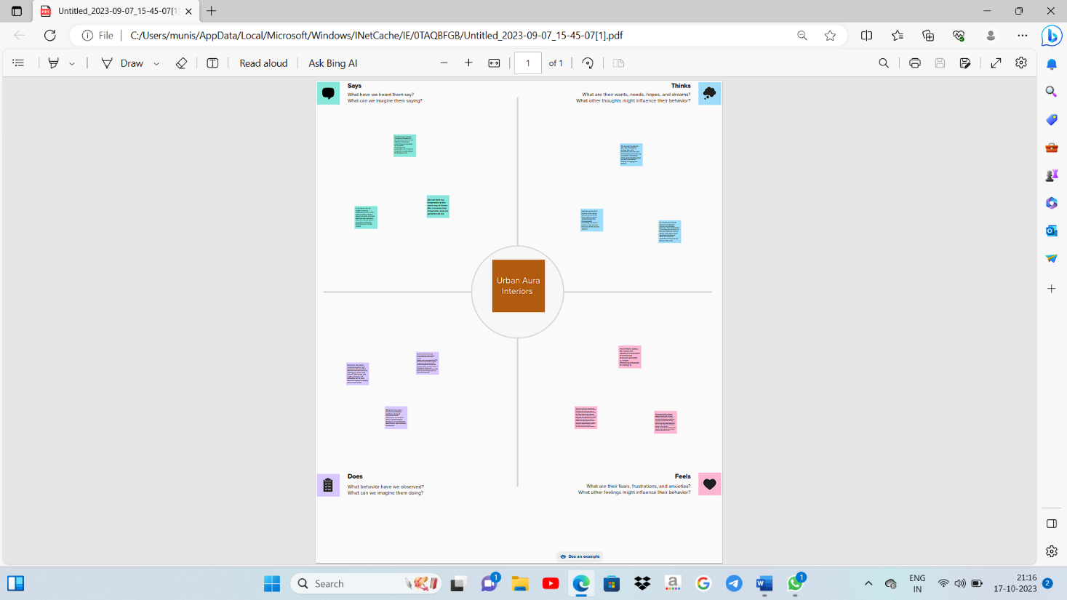

IDATION & BRANSTORMING MAP:

3. RESULT The taking after functionalities made a difference us within the victory of the project:

Profit & loss

BALANCE SHEET

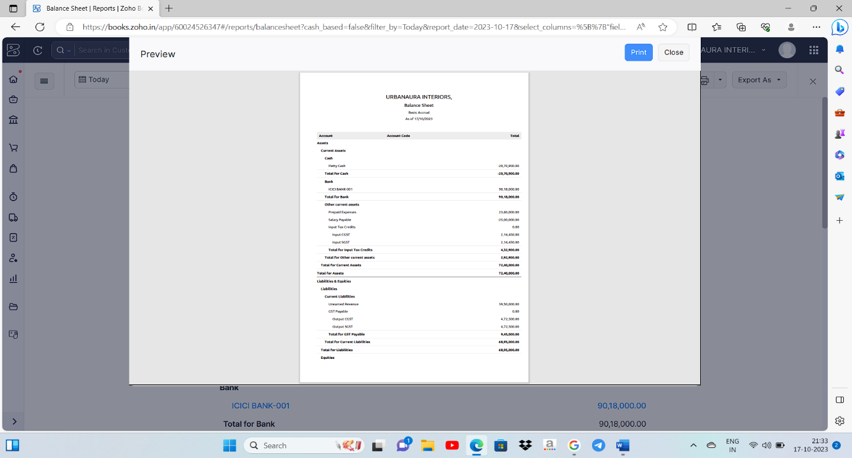

ADVANTANGES & DISADVANTANGES

Art and design have both advantages and disadvantages, and they serve various purposes depending on the context and individual perspectives. Here are some of the key advantages and disadvantages of art and design:

**Advantages of Art and Design:**

1. **Creativity and Expression:** Art and design provide a platform for individuals to express themselves and their ideas in unique and creative ways. It allows for the exploration of thoughts, emotions, and experiences.

2. **Communication:** Art and design can be a universal language, transcending linguistic and cultural barriers. It can convey complex messages and ideas effectively.

3. **Aesthetic Pleasure:** Art and well-designed objects can enhance our surroundings, providing aesthetic pleasure and improving the quality of life.

4. **Emotional Impact:** Art can evoke a wide range of emotions, from joy and inspiration to contemplation and catharsis. It can be a source of comfort and solace during challenging times.

5. **Cultural Preservation:** Art and design often serve to preserve cultural heritage and traditions, helping societies maintain a connection to their history and identity.

6. **Innovation:** Design, in particular, plays a crucial role in improving functionality, efficiency, and user experience in various products and systems.

7. **Economic Value:** The art and design industries contribute significantly to the global economy. They create jobs, generate revenue, and drive tourism.

8. **Education and Cognitive Development:** Art and design education can stimulate critical thinking, problem-solving, and spatial awareness in learners of all ages.

**Disadvantages of Art and Design:**

1. **Subjectivity:** Art and design are highly subjective, and what is considered beautiful or meaningful varies from person to person. This subjectivity can lead to differing opinions and conflicts.

2. **Financial Challenges:** Pursuing a career in art or design can be financially unstable, with many artists and designers facing income insecurity and limited job opportunities.

3. **Criticism and Rejection:** Artists and designers are often subject to critique and rejection, which can be emotionally challenging and lead to self-doubt.

4. **Commercialization:** The commercial aspect of art and design can sometimes compromise artistic integrity, as artists and designers may need to cater to market demands rather than pursuing their personal vision.

5. **Resource Intensive:** Creating and producing art and design often require resources like materials, equipment, and space, which can be costly and environmentally impactful.

6. **Time-Consuming:** The creative process can be time-consuming, making it challenging to balance artistic pursuits with other responsibilities.

7. **Isolation:** Many artists and designers work in solitary environments, which can lead to feelings of isolation and loneliness.

8. **Ethical Dilemmas:** Some art and design projects may raise ethical concerns, such as cultural appropriation, environmental impact, or social responsibility.

In conclusion, the advantages and disadvantages of art and design are intertwined and depend on individual perspectives, goals, and contexts. While they can be a source of inspiration, cultural preservation, and economic value, they also come with challenges related to subjectivity, financial stability, and ethical considerations.

APPLIAIONS

Art and design applications encompass a wide range of software tools and platforms that help artists, designers, and creative professionals to create, edit, and manipulate visual content. These applications are used for various purposes, including graphic design, illustration, 3D modeling, animation, photography, and more. Here are some popular art and design applications across different categories:

**Graphic Design:**

1. Adobe Photoshop: Widely used for photo editing, graphic design, and digital art creation.

2. Adobe Illustrator: Primarily for vector graphics and illustration.

3. CorelDRAW: A vector graphics editor with similar features to Illustrator.

4. Affinity Designer: A more affordable alternative to Adobe's tools.

5. Canva: A web-based tool for creating social media graphics, posters, and marketing materials.

**3D Modeling and Animation:**

1. Autodesk Maya: For 3D modeling, animation, and rendering.

2. Blender: An open-source 3D creation suite.

3. Cinema 4D: Used for 3D modeling, animation, and motion graphics.

4. ZBrush: Specialized in digital sculpting and 3D design.

5. Houdini: Known for its procedural and dynamic effects in 3D.

**Video Editing:**

1. Adobe Premiere Pro: A professional video editing software.

2. Final Cut Pro: Apple's video editing tool for Mac users.

3. DaVinci Resolve: Offers video editing, color correction, and visual effects.

4. Sony Vegas Pro: Popular for video editing and post-production.

**Digital Painting and Illustration:**

1. Adobe Fresco: Designed for digital painting and drawing.

2. Procreate: A popular iPad app for digital art.

3. Clip Studio Paint: Ideal for manga and comic creation.

4. Krita: An open-source digital painting software.

5. Painter: Offers natural media brushes and tools for artists.

**Photography:**

1. Adobe Lightroom: For photo organization and non-destructive editing.

2. Capture One: A RAW photo editor and asset manager.

3. Luminar: An AI-powered photo editing tool.

4. DxO PhotoLab: Known for its advanced image processing.

5. GIMP: A free, open-source alternative to Photoshop.

**UI/UX Design:**

1. Adobe XD: Focused on user experience and user interface design.

2. Figma: A cloud-based collaborative design tool.

3. Sketch: A macOS app for vector UI and UX design.

4. InVision: Used for prototyping and user testing.

**Web Design:**

1. Adobe Dreamweaver: A web design and development tool.

2. WordPress: A popular CMS with themes and plugins for web design.

3. Webflow: Allows designers to create and launch websites visually.

4. Wix: A website builder with design customization options.

These applications are essential for professionals and hobbyists in the art and design industry, and the choice of software depends on your specific needs and preferences. Keep in mind that new tools and software are continually being developed, so it's a good idea to stay updated with the latest offerings in the field.

CONCUSION

Art and design are essential components of human culture and creativity. They play significant roles in various aspects of our lives and society. Here's a brief conclusion on the importance of art and design:

1. Expression and Communication: Art and design serve as powerful mediums for expressing thoughts, emotions, and ideas. They enable individuals to communicate their perspectives and connect with others on a profound level.

2. Aesthetic Appeal: Art and design enhance the visual and sensory aspects of our surroundings. They can make spaces more beautiful, engaging, and appealing, whether in architecture, fashion, or interior decoration.

3. Cultural Identity: Art and design reflect the values, traditions, and identity of different cultures. They are instrumental in preserving and conveying the rich heritage of societies worldwide.

4. Innovation and Problem Solving: Design thinking is a problem-solving approach that is rooted in creativity. It is used in various fields, including product design, user experience design, and architecture, to develop innovative solutions to complex challenges.

5. Economic Impact: The art and design industries contribute significantly to the global economy. They encompass a wide range of careers and businesses, including fine arts, graphic design, fashion, and more.

6. Education and Learning: Art and design education foster creativity, critical thinking, and visual literacy in students. These skills are valuable in many areas of life and work.

7. Emotional and Psychological Well-being: Creating and experiencing art and design can have a positive impact on mental health and emotional well-being. Engaging with art can be therapeutic and cathartic.

8. Social and Political Commentary: Art and design often serve as a platform for social and political commentary, shedding light on important issues, sparking conversations, and promoting change.

9. Personal Enrichment: Engaging with art and design can be personally enriching, providing individuals with a sense of accomplishment, satisfaction, and personal growth.

In conclusion, art and design are integral to our culture, society, and daily lives. They contribute to our understanding of the world, enrich our experiences, and inspire creativity and innovation. They are versatile tools for self-expression, communication, and problem-solving, and they continue to evolve and adapt to the changing needs of our globalized and technologically advanced world.

FUTRE SCOPE

The future scope of art and design is dynamic and promising, as these fields continue to evolve and adapt to the changing demands of society, technology, and culture. Here are some key aspects to consider when discussing the future of art and design:

1. **Digital Transformation**: Technology will continue to play a significant role in art and design. Digital tools, software, and virtual reality are already being used to create, showcase, and interact with art and design in new and exciting ways. The integration of technology and art/design will likely become even more seamless in the future.

2. **Sustainability**: There is a growing emphasis on sustainability in art and design. Eco-friendly materials and practices are becoming more prevalent, and designers are increasingly focusing on creating environmentally responsible products and artworks.

3. **Augmented and Virtual Reality**: The use of AR and VR in art and design will expand. Artists and designers can create immersive experiences, interactive installations, and virtual galleries. These technologies offer new dimensions for creative expression and audience engagement.

4. **Artificial Intelligence (AI)**: AI is being used to generate art, aid in the design process, and enhance user experiences. AI-driven tools can help artists and designers with everything from generating ideas to automating repetitive tasks.

5. **Collaboration Across Disciplines**: The boundaries between various creative disciplines will continue to blur. Collaboration between artists, designers, engineers, and scientists will lead to innovative and cross-disciplinary projects.

6. **Personalization**: Customization and personalization will be key in the future of art and design. Technology allows for tailor-made creations, and consumers increasingly seek unique, personalized art and design pieces.

7. **Cultural Diversity and Inclusivity**: Art and design will continue to reflect and celebrate the diversity of cultures and perspectives. There will be more emphasis on inclusivity, breaking down barriers, and telling untold stories.

8. **Artificial and Natural Fusion**: Artists and designers are exploring the intersection of artificial and natural elements. This fusion leads to creations that blend the digital and physical worlds, often highlighting the relationship between humans and technology.

9. **Sustainable Fashion and Eco-Design**: In fashion and product design, sustainability will remain a dominant theme. Eco-friendly materials, circular design practices, and sustainable production methods will become even more prevalent.

10. **Wellness and Design**: The connection between design and well-being will grow. Spaces and products will be designed with a focus on enhancing mental and physical health, comfort, and tranquility.

11. **Artificial Creativity**: The ethics and implications of AI-generated art and design will continue to be explored. This challenges the traditional definition of what it means to be a creator and raises questions about originality and authorship.

12. **Online Galleries and Marketplaces**: The online art and design market will continue to grow. E-commerce platforms, NFTs (non-fungible tokens), and blockchain technology are changing the way art is bought and sold.

13. **Cultural and Social Commentary**: Artists and designers often act as social commentators. As societal issues evolve, they will use their work to engage with and critique these changes.

14. **Educational Opportunities**: Art and design education will adapt to meet the demands of the future. Online learning, digital tools, and interdisciplinary programs will become more common.

In summary, the future of art and design is multifaceted and highly adaptable. It will continue to be shaped by technological advancements, environmental concerns, societal shifts, and a growing desire for personalization and inclusivity. Artists and designers will play a crucial role in addressing and reflecting these changes in creative and innovative ways.